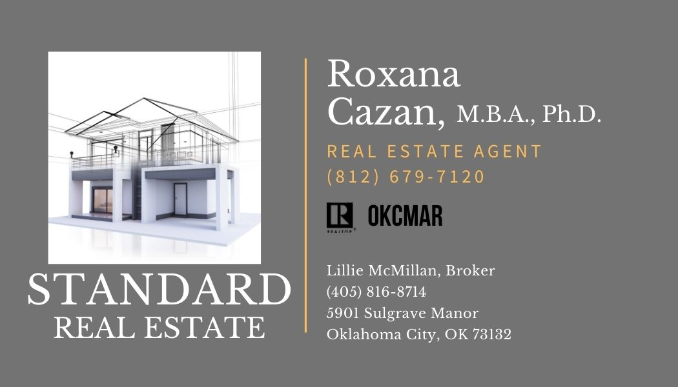
Hello neighbor,

My name is Roxana Cazan, and I am an expert in short sales. I wanted to reach out to you because I noticed that your home is coming up for foreclosure and is advertised for auction in the Oklahoma County Sheriff Sale. I know how frightening this may feel. We spend a lifetime building a home, and suddenly all that is slipping away. I know you love this place, and I want to help you get something for it that you can live with.

Banks usually need 30 days to complete the paperwork needed for short sales, so you have to act soon. I work with Standard Real Estate, whose broker, Lillie McMillan has 25 years of experience working on short sales. We will do our best to ensure the process is easy for you and to prevent a huge loss which may happen if your property goes for auction.

Please reach out to me at 812-679-7120. We will make sure you have a say in what is happening to your home.

Call today! 812-679-7120.

Sincerely,
Roxana Cazan

