INTEGRATED MARKETING COMMUNICATION PLAN
DEPARTMENT OF LITERATURE & LANGUAGES
Saint Francis University, PA

I. Context & Background
As a department that offers service courses to the university’s General Education Core Curriculum as well as several major and minor programs of study in English and world languages, the mission of the Literature & Languages Department (L&L) at Saint Francis University (SFU) is to equip students with the requisite skills to communicate effectively with others. Despite the L&L’s exciting goal, the department has noticed a dramatic decline in enrollments over that past ten years. This trend mirrors similar national or even global developments. A 2015 survey revealed that between 2008-2014, graduates of the English major are typically not using their degree in their employment; are unemployed; or are unsatisfied with the utility of the degree. With the departure of two skilled English faculty members, faculty job security and the department's wellbeing are threatened.

Unique Selling Proposition (USP)
The L&L department’s mission is to teach students to become better writers in all fields of study. This is why they recently proposed a new, refreshing take on English: Writing in the 21st Century. English majors will learn and develop their talents in writing and communication as important skills sought after not only by academic employers but also by industry employers such as: business companies, software companies, oil and gas operators, alphabet agencies, medical employers, pharmaceutical, chemical, and biochemical companies, urban planning and development employers, and many more. Considering local culture, local high school interests, student success stories, and regional competitors, an emphasis on writing represents a very attractive USP.

Competitive Analysis
Choosing SFU for a degree in the humanities is not easy considering the high costs of education and the long term loans students will have to pay after graduation. However, those students who choose to study the humanities could opt for SFU among regional competitors such as Penn State Altoona, University of Pittsburgh at Johnstown, Juniata, St. Vincent University, or Seton Hill University, whose English programs focus either on literature or on creative writing specifically (or a combination). Among these regional competitors, Penn State Altoona and Seton Hill also use social media platforms (in particular, Facebook) to reach potential students interested in the humanities. I propose we test this tactic and assess its viability at SFU, by reorienting the department's mission and vision to serve writing in the 21st century.

Every four years, when the department goes through a program review, a document gets compiled, which contains among others a comparative analysis of the curriculum. For the past two reviews, the department identified gaps in their offerings when compared to competing departments at other local universities. In fact, my hire was the result of a recommendation made by outside reviewers to add world and postcolonial literature requirements in the curriculum (at the moment, the literature survey courses stop in the mid-20th century; the curriculum addresses strictly state-requirements for middle school and high school Language Arts instruction). While a host of new courses were added, they were deemed electives and were rarely taken by students who wanted to complete the requirements (I taught one postcolonial course to 2 majors in 2015). Compared to the English offerings at Penn State Altoona, Seton Hill, Indiana University of Pennsylvania, Juniata College, and others, the current English curriculum is outdated. Attempts to revive it have been made unsuccessfully. This is why I propose that the new USP outlined above be adopted.

If the USP is implemented, the curriculum, that is, the paradigm of required courses for English majors, must be fully revised and approved by the Curriculum Committee. In addition to curriculum review, an analysis of competitors' English/Literature department websites is necessary, in order to evaluate what the L&L Department can learn and how to focus their USP approach.

Goals
As a response to this phenomenon, I argue that a better digital marketing strategy that manages to comfort parents and to produce employment results after graduation may be able to salvage the L&L Department at SFU. In the coming year, I propose the development of the following marketing goals:
- Establishing brand awareness and leadership in all their digital strategies consistently.
- Constructing a social media presence that reflects the university-created website and enhances it. The immediate goal would be to increase social media engagement by 50% in 2021.
- Increasing traffic to the L&L Dept. pages on the university website by 5% in 2021.
- Reaching potential customers through e-mail marketing. The goal is to reach out to at least 300 candidates every semester, achieve a 20% e-mail open rate and 5% enrollment rate in 2021.
- Developing a stronger outreach in the community and a visible presence.
- Enhancing direct marketing through open houses and similar events.

SWOT Analysis for the L&L Department
Strengths:
1. small classrooms that allow students to receive more attention from their instructors
2. a strong student-professor relationship based on specific interests
3. a tightly knit community resembling a family
4. a visionary Franciscan attitude to life, learning, faith, and the community
5. a set of unique scholarly opportunities such as grants, conferences, etc. that interested students can easily take advantage of

Weaknesses:
1. a small endowment that does not allow much modern development
2. insufficient classroom and laboratory space
3. insufficient modern teaching technology
4. insufficient faculty members to put into development the USP (only one faculty member is a trained writing specialist; in addition, there are three Americanists, one of whom teaches majors on a regular basis; and one British literature specialist close to retirement (none of the other faculty is prepared to take over this area upon this faculty member's retirement); there are no writing specialists working with multimedia; there are not creative writing specialists (poets, novelists, graphic novelists, social media writers, and other writers).
5. faculty and staff worried about their job stability

Opportunities:
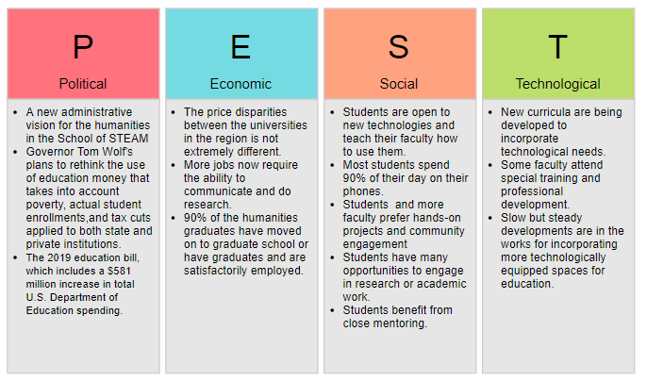

Threats:

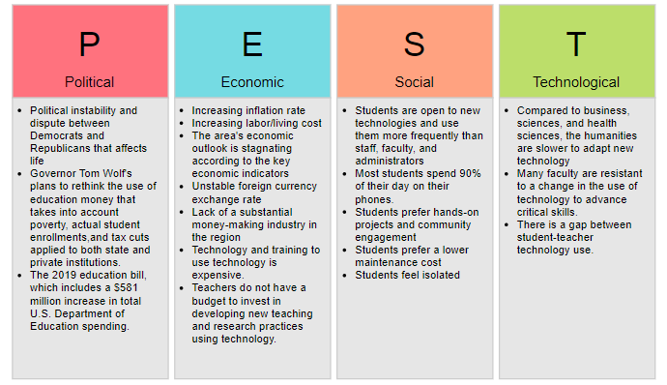

Environmental Challenges:
- location—far from major metropolitan areas
- the aftermath of the steel and coal industries
- dependency on vehicles for mobility
- space for campus housing extensions
- a conservative or religious milieu that may be uncomfortable with some humanities discourses (for example, women's rights, the LGBTQ)

The Catholic University
Pro
A Franciscan Catholic approach to education emphasizes service and community engagement, an appreciation for environmental sustainability, stewardship, respect for the Christian tradition, and respect for human and animal life in any form. These are attractive options for high school graduates and their families, especially for locals who are already familiar with the university and/or with the Catholic culture.

Against
The discipline of English will inevitably address a liberal agenda because literature is often a platform that decries social evils. This may not sit well with some parents.
The Catholic and Franciscan culture are not an attractive marketing strategy for Gen Z students, although they may be for their parents.
The Catholic mission does not translate well student's possibility of employment and degree usability/practicality.
Local high school students who have graduated from a Catholic institution tend to be attracted either to larger and urban Catholic universities or to laic institutions (only 1-2% of L&L students are Catholic heritage students).

II. IMC Plan
A. Target Market
The table below offers a brief analysis of the target market to be considered for the next five years.
 | Synopsis | Future Targets
Place of Origin | Ninety percent of SFU consumers tend to be local or Pennsylvania students. About 7% come from surrounding states, either MD, NY, or OH. About 3% come from others states in the US, such as FL or CA, or from other countries. | There might be space to target more foreign students.
Age | A 95% of the students interested in the humanities are recent high school graduates, 17 or 18 years of age. | The L&L Department should offer a graduate degree to attract older professionals, especially teachers who need specializations. Indiana University of Pennsylvania offers this option.
Schooling type | A small percentage—10%—of the humanities majors are bringing in community college or college-in-high school credits. A very small percent of the humanities majors—2%—are home-schooled. A majority have attended Catholic high schools (70%).
SAT score | Their typical average SAT score is 1000. | To increase the quality of the program, the L&L Department and SFU must enhance the score demands. The L&L department could also prepare their own admission process, whereby they ask for writing or digital humanities samples from the candidates.
Race and ethnicity | Most of SFU's humanities majors are white (95%), a few are black or African-American (4%), and very few identify as other races and ethnicities (1%).
Economic status | Most of the L&L students come from lower middle-class families (95%). | By updating technology and developing technology-based courses, L&L may attract a thicker middle-class community, who has the means to invest in the future by purchasing technology power.
Family type | About 50% of L&L students come from single-parent families (typically mother). | L&L should also emphasize the role of employment after graduation, enhance their curriculum, and discover opportunities for student internships or other job affiliations in order to satisfy the consumers they already have and to attract a more diverse family type (modern family arrangements with LGBTQ parents or adopted children).
In an analysis performed by the School of Business, five categories of students have been identified as potential candidates for SFU.

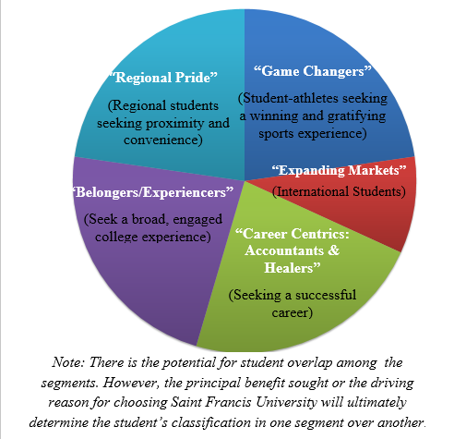
Figure 1 Segmentation courtesy of Dr. Randy Frye
While in the past, some English majors belonged to the Game Changers and Expanding Markets segments, most majors identify as Regional Pride. Typically, Career Centrics do not see English as a viable option. While difficult to accomplish, the Department may actually seek to attract these by switching emphasis to writing in the 21st century as a career-enforcing skill. Some Belongers/Experiencers seek the Department looking for a second major or a minor, and these students are typically difficult to retain over the four years.
B. Mission
While this marketing campaign aims primarily to attract new students to the department, it should also focus on the following:
- Increase brand awareness: allow audiences to understand the unique selling proposition of this department in the context of higher education in PA.
- Retain majors after admission.
- Build a brand image that marries the USP with the university's "Become that Someone" message.
- Help launch awareness of new opportunities to the outside world: events, the high school writing contest, the Multicultural Week, etc.
- Face competition effectively by offering new/unique services.

To achieve these objectives, the L&L department would:
- Research, design, and implement a departmental online and in-person orientation program that includes mission, vision, and strategic angle, key steps in achieving the degree, key student success stories, and specific media strategies.
- Streamline their website according to suggestions I outline below.
- Ensure that the information provided is updated and error free.
- Highlight the specific achievable skills/knowledge/ability as a major in this department.
- Streamline with university marketing and recruitment practices.
- Institute a clear timeline and abide by it.

While the promotional objectives of this campaign should focus on informing, persuading, reminding, and connecting, the foremost objective to be pursued should be persuading. Potential students are already familiar with the existence of the department, as it has been open for many decades. They are also familiar with what an English degree grossly entails. Their greatest fear is the lack of professionalization such as degree offers. Families in the region tend to desire that their children pursue careers ending in remunerative and secure jobs. The economic recession will further underscore this desire, and so the department must consider ways in which they can persuade that studying English with an approach to writing can and will prepare majors for the job market and render them employable. More so, the regional public must understand that an education for the future must entail the development of critical and analytical skills, good writing habits, and clear communication channels, and that all of these can only be acquired while studying English.
C. Message
Considering the 5 Ps of marketing: product, price, promotion, place, and people, the L&L Department should focus on the elements below:

The graphic above underscores three elements dependent upon each other: one focuses on customers and seeks to understand what kind of students the department wants to attract and what channels should be used. As explained above, the most attractive segment are Regional Pride, but efforts should be out to address the Emerging Markets, Game Changers, and Career Centrics. An analysis of technology and communication among Gen Z-ers should also help identify the fittest channels for addressing these segments. The second element asks what needs should the department seek to fulfill. They must seeks to clarify what majors can achieve with a specialization in Writing. They must address the market needs (local and national) for qualified writers. Most importantly, they must guide the majors towards specific careers outside the traditional ones (teacher or graduate student). The third element asks what price a student is willing to pay for this degree. Although a pragmatic question, this should be considered so that the value of the degree can be accurately communicated.
SFU's Literature & Languages Department empowers young people to find their own voice, write their story online and offline, and use their writing to inspire others, to defend the underprivileged, to conquer emerging technologies, and to change the world for the better.
The department should create similar videos as those below, with an emphasis on writing for the 21st century.
https://drive.google.com/drive/u/0/folders/1zDErH-8ZarHd2Iia94ZCCi7QRwW0U-fM
https://www.facebook.com/watch/?v=10155219137273093
D. Methods

i. Digital Marketing

Brand Consistency
Through all the digital marketing channels described below, L&L should aim to maintain brand position within SFU’s branding campaign. This can be achieved by crafting a consistent content, style, and design of all ads. The L&L Dept. needs to follow SFU brand standards across all digital marketing channels. The department’s “voice” needs to be consistent whether it is on the website, social media, email, or on other channels. The marketing department at SFU already has a branding manual set in place for all SFU users available here. L&L would ensure that they follow it.

Website / SEO
The website is an important go-to hub that describes not only what L&L does, but who they are and who their students are. The website is also important because it has the potential to make SFU English look distinguishable from all the other English departments at surrounding universities.

The current site has a design meant to enhance the overall SFU brand awareness. In order for the website to speak to the USP, L&L should develop new content that is relevant not only to the department but also to the customer. This content should be concise, updated, and easily shareable. Good content on a website is typically shareable via e-mail or social media. The content should emphasize writing in the 21st century as the major skill; I propose the following:
- L&L should revise the primary landing page of the department to reflect the USP.
- L&L should revise all Literature & Languages pages to reflect the USP. For example, the faculty page must highlight qualities that emphasize the USP (what kind of writing have the faculty been involved in; multimodal writing must be considered).
- The Students’ Success Stories page is hard to find and is text-heavy. The page needs to be visible and accessible to all potential customers.
- L&L should be selective in how many such success stories they present. At the moment, the page is overwhelming; L&L has attempted to include every success story they had over the past 8-10 years. While a customer’s attention span will allow them to browse over the first 5, the customer will not read all entries in detail. In order to feature students’ experiences and employment after graduation, L&L should redesign the Students’ Success Stories page to contain 5 short videos that are up to 40 seconds long and that refer to the USP. With access to a tool such as Google Optimize or Optimzely, L&L could test
  - Whether the page contains a certain type of story, its bounce rate (we would aim to publish only stories with the lowest bounce rate), and its time on page (we would select only stories that have the highest user time spent on the page).
  - Video testimonials versus short stories with images
  - A “teaser” text on the main page. If a user/potential customer clicks on this link, the link would take them to the full story on its own page.
- L&L should use graphics to depict the skills acquired or the utility of a degree in English with emphasis on writing for the 21st century.
- L&L should display a comparison graph referencing other programs and their offerings to argue that their offer is unique and the most valuable. (L&L has already asked SFU Marketing if this is a possibility, and they received a positive answer).

Overall, L&L should aim to increase traffic to their pages on the university website by 5%. The Appendix describes the traffic data for the domain francis.edu collected via SemRush. While the department is unable to assess the traffic to specific pages on the francis.edu website so far, the landing pages report indicates that English or Literature & Languages does not feature among them. The SFU Marketing team could grant L&L access to Google Analytics for their L&L pages specifically (I have already received a verbal agreement for this access). This access could allow them insight into,
1) how much traffic they are really getting,
2) where that traffic is coming from
3) how long potential customers are spending on their pages, or
4) which pages getting the most/least traffic.
This data is very valuable in assessing what works and what does not in terms of a marketing strategy. If L&L could increase the number of visitors to the department’s pages, they could then target these visitors with remarketing and e-mail marketing by setting up a sign-up CTA. L&L could set up a remarketing campaign in Google Ads and on social media in order to remarket specific pages to the visitors.

All these efforts could lead to a higher conversion rate (number of students enrolled in a given period) for English majors. To this date, the conversion rate of visitors to the website to customers is not monitored. However, L&L would need to keep track of this rate in order to measure their success. Most students enroll via an online application (even students who visit SFU in person are asked to complete a short online application form). This could be used for L&L measurements. L&L would use Google Analytics to monitor this conversion rate.

SEO
In order to increase traffic to the SFU website by 5%, simple searches must first be determined. First, one should settle on determining topics and long-tailed keywords associated with the services offered. I tested looking for “English Departments in Central Pennsylvania” or “undergraduate writing in Central Pennsylvania” and noticed that the L&L department was not mentioned on at least the first 10 Google results pages. Second, one should determine a topic cluster (see Figure 1) that links to the respective pillar pages on the L&L website and serves their USP. The page content must be consistent with SFU and L&L brand identity and with all other marketing strategies.

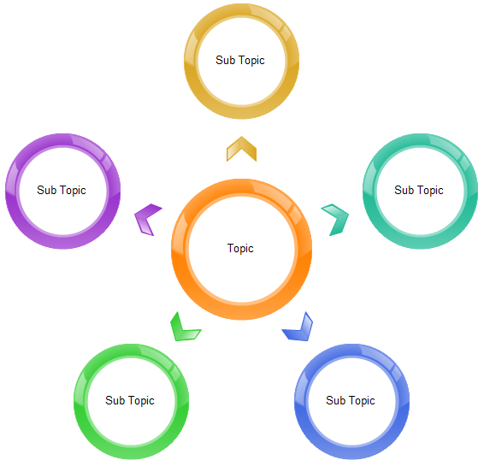
Figure 2: Simple Topic Cluster
An important percentage of visitors to the domain francis.edu comes from searches as shown in Figure 2. While this representation does not indicate traffic to L&L specific web pages on the SFU domain, one could assume that rate to be close to 0.1%. A solid SEO could help increase this rate as well as other traffic rates to as close to the target of 5% as possible. Perhaps L&L could also consider paid search in assisting with redirecting traffic on specific kinds of keywords. In this way, they could integrate new page content into searches almost immediately.

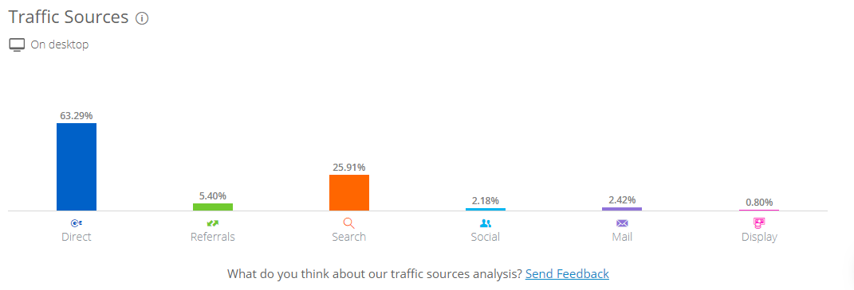
Figure 3: Traffic by SimilarWeb.com

Social Media Marketing
In order to reach the goal of redirecting traffic towards our pages on the SFU website by 20%, L&L should maintain social media presence on three platforms: Facebook, Instagram, and Twitter. While the Facebook audiences tend to be composed of parents of potential students, Twitter and Instagram would target the students themselves. The types of posts would include contests and event announcements, videos and video testimonials, images, and links to student success stories.

Every semester, the L&L department receives at least one work study intern. Rather than assisting certain faculty members, the intern's main task could be to populate social media with posts, announcements, and marketing materials that would attract visitors to the website. The department already possesses a camera and an IPad which can be used by the intern to this end. The intern could create a social media calendar to remind them when to post. The department would determine what kinds of social media posts attract potential customers, and create content that is appealing to them for a variety of reasons. For instance, many high school students begin applying to universities in the fall semester of their senior year in high school. However, they tend to have made up their minds about what college they want to attend in their junior year of high school. This is important to know, so that L&L could target a certain kind of population with specific messages (for example, the English high school writing contest could be advertised via social media for high school juniors). Tools like HootSuite could help schedule posts across a variety of social channels. Another important task on social media would be to respond to interactions. These tasks will be outlined in a clearly written job manual. I envision this to be a living document that would be updated every semester by the department chair.

The department would measure customers’ awareness using metrics such as volume and reach. A subset of goals here that would potentially drive more traffic to the department website are:
- Engagement (the number of people who share or engage with L&L posts), which renders how well L&L audience members perceive the department and their willingness to interact with the department.
- Sentiment, which measures how users reacted to content, brand, and hashtags.
L&L should also engage in a social media competitive analysis to understand what messages our competitors use that drive most engagement. Through “shares” on social media, the department could enlarge their followers. However, Paid Search could also help with choosing what audiences L&L wants to follow them. Finally, L&L would track social media engagement using a tool like Sprout Social in order to manage their success.

Email Marketing
E-mail marketing will also need to be incorporated into the L&L marketing strategy. Services such as MailChimp or 123SignUp can be used to create audiences on social media. The department must ensure though that the software they choose is free of cost or very modest and can be used very easily. L&L should target three kinds of customers: 1. Visitors to the website, 2. Candidates interested in the major that the Recruitment office provides periodically, and 3. Social media lead generation campaign followers. The second category of targets is easily accessible through a university compiled excel file. The department could create a sign-up CTA on social media and on their website through which they could access contact information for the visitors to their site and social media profile.

Another way of widening their e-mail list is to create a sign-up with the L&L writing contests. The L&L Department organizes three writing contests annually, one of which targets high school students. The students could be asked to submit their contributions via a form that collects their personal details and contact information. It is important that the L&L Department personalizes their e-mails. In the past, L&L has been using bulk e-mails to contact potential customers. For example, out of a list of 260 potential customers e-mailed, 17 e-mails bounced back and only 3.8% of those contacted responded to the e-mail. A personalized e-mail may return more follow-up responses. While the department is unable to measure how many of the contacted individuals open their e-mail when bulk e-mailing is being used, a service such as MailChimp could determine that towards the goal of establishing a 20% e-mail open rate.

Segmentation is an important tool as well, because the department is addressing different kinds of potential customers in customized, interest-specific ways:
- Students who are looking for a program at SFU
- Students who are looking specifically for English at any university
- Students who are in the process of applying as “exploratory” majors
- Students who are in the process of applying as “English” majors
- Students who are in the process of applying at SFU with an English second interest
- Students who have applied and are admitted to SFU as English
- Students who have applied and are admitted to SFU with an English second interest

L&L could address potential customers via e-mail in the following way:
Initial welcome e-mail
- If the e-mail is opened but no action taken, additional student success story or unique opportunity e-mail
- If the e-mail is opened and further action is taken (links are clicked), additional e-mail about specific SFU opportunities and invitation to campus
- If second e-mail is opened but no action taken, additional e-mail about specific SFU opportunities and invitation to campus
- If second e-mail if open and further action taken, invitation to apply e-mail
- If the e-mail is not opened, a different initiation e-mail

ii. Event or Experience Marketing
Immersive, live, and experiential campaigns help deliver the message by engaging consumers using branded experiences. To this end, I propose the organization of a summer literature fair that extends over three to four days. The event would be hosted on campus by the L&L Department and would invite all surrounding area students and families. The fair would be offered free of charge and would contain activities such as a poetry/short story writing workshop, a children's book writing event, a spoken word contest, a Shakespeare ad hoc theatre, a small book fair, a reading offered by an established writer, a costume show based on literary characters, and an information booth about the English major and the department. In order to fund this event, I would apply for an EQT Foundation grant.

This event would attract students of all ages, and not solely high school students, who are typically already sworn to a certain major. It is important to engage younger students in unexpected ways, creating touch points that they will remember.

Another event that I consider absolutely necessary in the region is a week-long summer training for teachers. School teachers need a certain number of training hours a year to maintain their certification. The department could offer this opportunity as a week-long workshop. I suggest that the first couple of summers this workshop is offered, it would be offered free of charge. This would create a base of loyal customers, and should be looked at as part of a faculty's 9-month contract requirement. for this reason, it should be organized in May. I also suggest that the department looks into state-funds and grants they could acquire to organize this workshop.

iii. Direct marketing
Apart from e-mail and social media marketing, I suggest the use of a different channel for direct marketing: high school visits. While at SFU, I would contact English teachers in the region and ask to come to their classes and do a presentation. Usually, teachers are happy to get the day off or to do something outside their normal routine. I suggest that every semester, an L&L faculty reaches out to the local high schools and offers to hold presentations. All faculty should participate through rotation. It is important that the department does not only invite high school students and teachers to attend their events but also travels to meet them in their environment. These presentations should entail a fun activity, a game, or a compelling lecture. They must culminate with a call to action, such as signing up for our e-mail list, or signing up for a campus visit.

At SFU many departments offer college-in-high school classes. There are collaborations with local Catholic colleges that allow SFU professors to teach high school classes. None of the L&L faculty have done this. They must develop a college-savvy course that they could offer to high school students.
E. Money
In order to implement this marketing plan, the following budget is ideal
- $50,000 annually for a new faculty position who will be assigned half the teaching load and half marketing and recruitment for the department. If the department's focus is on writing, they need at least one more writing specialist besides Dr. Thomas Brennan. Right now, the department offers several courses in Creative Writing with no faculty (after my departure) who specializes or has a degree in Creative Writing. I suggest they open a full position for a Creative Writer faculty/Marketing Specialist who can split their time between teaching a half load and putting into action the marketing plan in collaboration with the University Marketing Office, whose employees are already multi-tasking.
- $500 for the creation of the promotional videos outlined in Digital Marketing/Webiste/SEO.
- $1,200/semester for a work study intern position charged with maintaining social media presence.
- (optional): $10,000 grant through the EQT Foundation; can be obtained in two consecutive years.
F. Measurement
In analyzing and reporting their ROI, L&L must distinguish between:

Vanity KPIs |  | Valuable KPIs
Web traffic  Time on site  Keyword rankings  Bounce rate  Social media followers  Impressions  Page views | versus | Conversion rates (rate of applicants to our program; rate of potential customers contacting us or a representative to make an inquiry; rate of visit requests; subscriptions to our e-mailing list)  Customer acquisition costs
Table 1: KPIs

The department must be aware of the fact that Vanity KPIs may actually not work if the college is not receiving on-site campus visits or student enrollment. While Google Analytics can help track customers’ and potential customers’ engagement with the L&L website, the certain KPI metrics need to be measured in order to achieve the goals listed in this plan (see Table 2). None of these can be achieved without ensuring that the department maintains:
- Brand awareness
- Brand consistency to the SFU brand
- Brand consistency across all their marketing efforts

OBJECTIVE | Establish brand identity across all marketing strategies | Increase website visits | Increase rate of open e-mail
GOAL | New visitors; build fan-base | Improve conversion rate | Improve conversion rate
KPI | Web traffic  Time on site  Keyword rankings  Bounce rate  Social media followers  Impressions  Page views | Conversion rates (rate of applicants to our program; rate of potential customers contacting us or a representative to make an inquiry; rate of visit requests; subscriptions to our e-mailing list) | Conversion rates (rate of applicants to our program; rate of potential customers contacting us or a representative to make an inquiry; rate of visit requests; subscriptions to our e-mailing list)
TARGET | Consistency across all marketing media | By 5% | By or to 20%
Table 2: Metrics

III. Recommendations for New Approaches to Promotions
The SFU L&L department should consider marketing the majors to students interested in writing opportunities. Collaborative opportunities with the School of Business must be considered. Marketing ads should focus less on the Catholic identity of the school and its Franciscan mission and more on the following:
- students telling their stories
- students making a change in the region (town, area) through writing
- the Franciscan mission can help students use their privilege to empower others through writing
- writing is a valuable skill in any profession
- writing helps one become someone

IV. Concluding Thoughts

With appropriate administrative support, a marketing specialist could implement this plan or a plan similar to this and could increase the number of students signing up for majors in L&L. The department must be open to trainings, collaborations with other schools and departments at SFU, voluntary and unpaid work, and a willingness to change.

Appendix – Web Navigation Research 2019

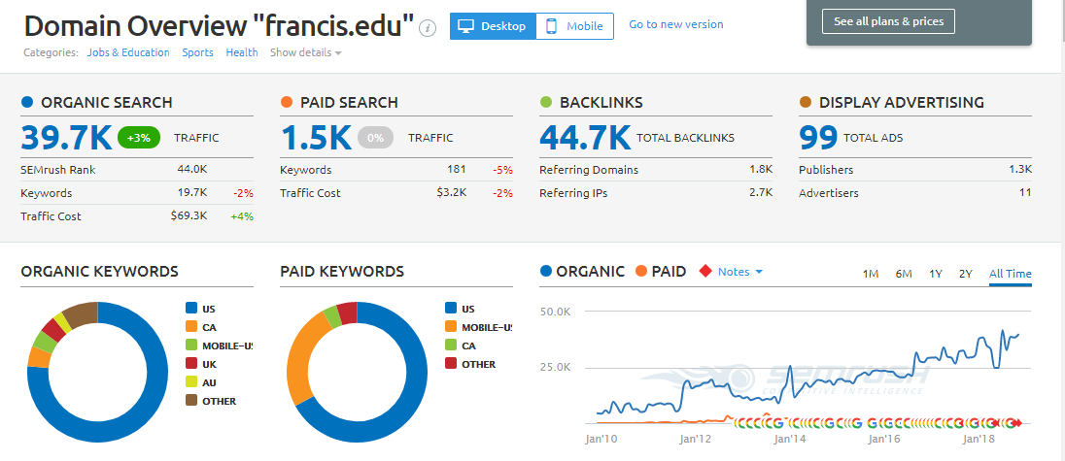

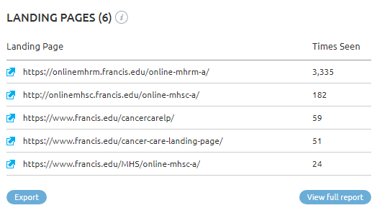
Data extracted from https://www.semrush.com/dashboard/

Nationwide, it has been amply noted that the humanities are no longer enrolling the same numbers of students they used to. Scott Jashik (2017) of Inside Higher Ed argues that the highest declines in enrollment have been noticed for majors like English and History, with a 16% drop in the past six years. Helen Sabrowsky (2018), John Fea (2016), Frank Miles (2018), and Fareed Zackaria (2014) all argue that despite the immense power of a liberal education to teach critical thinking, analysis, communication, and retooling, many students and their parents today choose majors that can, in a sense, guarantee employment after graduation. Students and their families alike fear the fluctuations of the market whose greatest recent hit took place in 2008. They reject the humanities as fields that cannot produce secure and pragmatic jobs. Unlike Jashik and the rest however, Benjamin Schmidt (2018) writing for The Atlantic underscores that there is actually no crisis in enrollment for the humanities disciplines because, if one considers enrollment trends since the 1950s, one could interpret the contemporary low curve as simply a case of “history repeats itself.”
$49,344 is the budget one must plan for a year of tuition and living expenses. In contrast, Pennsylvania State University charges a $36,344 for in-state all expenses and $51,572 for its out-of-state counterpart. Slippery Rock University charges $24,377 and $28,123 for in-state and out-of-state tuition and other costs respectively. The University of Pittsburgh asks for a $33,250 in-state and a $44,812 out-of-state all expenses included tuition price, while Seton Hill University charges $32,520 for in-state and for out-of-state tuition alike.
The L&L Department has been offering that in the past, but with the critical enrollment numbers, the strategy had to change. This is why they selected the focus on writing.
In order to maintain a business formality, I am referring to all potential candidates in English at SFU as customers.
There seems to be an overall pushback against "selling the humanities out" for careers that are professionalizing or licensing upon graduation. While I believe in the ideal that everyone should study literature for the simple fact that it opens us up to the world and makes us better humans, from a business perspective this is not a selling proposition for parents or students alike. This is why, in order to survive the economic crisis and these times, English needs to be reinvented. I believe in change, in reorientation, but many of those who have served for longer than me do not.
MailChimp offers a Forever Free plan for organizations that have fewer than 2000 subscribers.

